**Vivekanand Education Society’s Institute of Technology**

**Department of AI &DS**



**Subject: Social Media Analytics**

**Class: D16AD**

| **Roll No: 30** | **Name:** [**SUHANEE KANDALKAR**](mailto:2021.suhanee.kandalkar@ves.ac.in) |
| --- | --- |
| **Practical No: 9** | **Title:** Competitor Activities Analysis |
| **DOP:** | **DOS:** |
| **Grades:** | **LOs Mapped:** |
| **Signature:** |  |

**Title:** Competitor Activities Analysis

**Aim:** To Analyze competitor activities using social media data

**Theory:**

Competitor analysis using digital and social media platforms provides actionable insights into a product’s market position, customer perception, and performance. Key platforms like **Google Trends**, **SimilarWeb**, and **Twitter** help assess public interest, traffic patterns, and sentiment around various brands.

In this experiment, we:

* Compared **ChatGPT-4**, **Google Bard**, and **ChatSonic** using SimilarWeb (traffic metrics),
* Scraped tweets related to each tool,
* Performed sentiment analysis to measure user perception,
* Visualized results using bar graphs to draw comparisons.

This form of analysis enables businesses to understand where they stand relative to their competitors and identify potential areas for improvement or differentiation.

**OUTPUT:**

[SMA_exp9_30.ipynb](https://colab.research.google.com/drive/1BtsyzStSFb4wVXQYRarlKQ44H_o7_0yx?authuser=0#scrollTo=EfCKafbK2TO9)

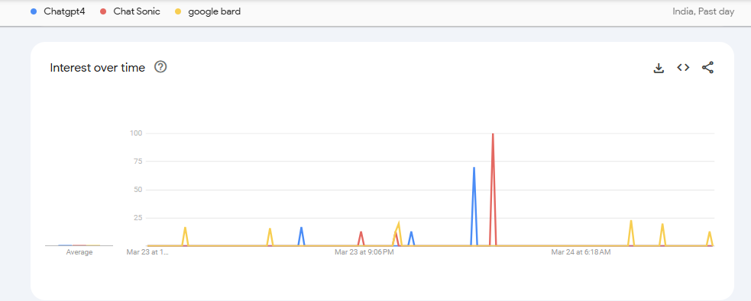

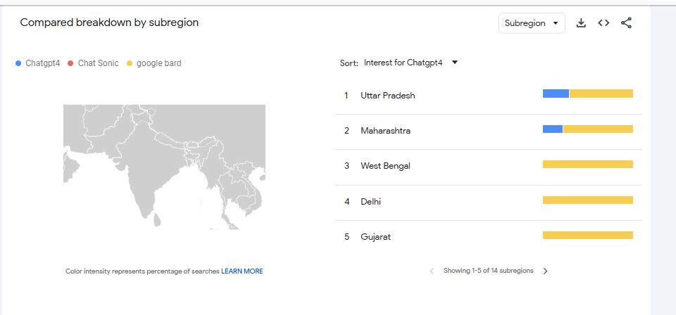

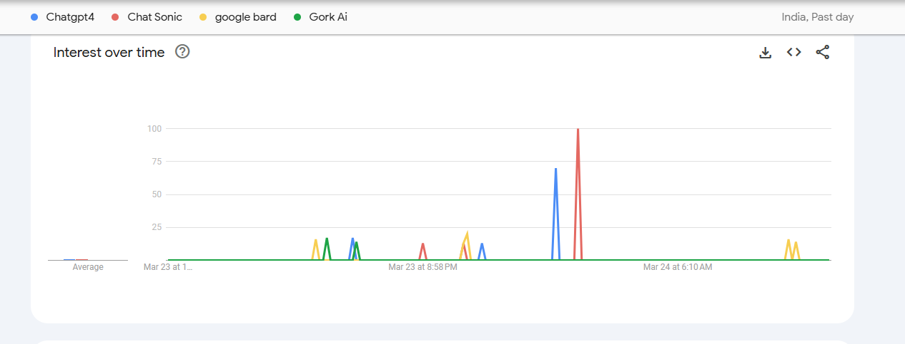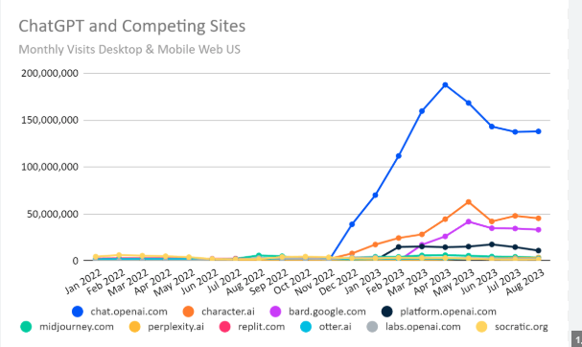

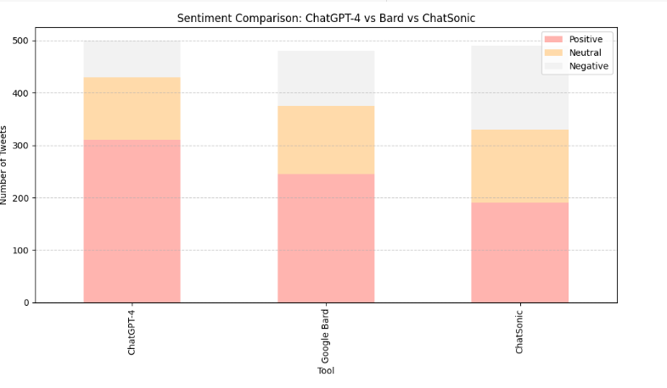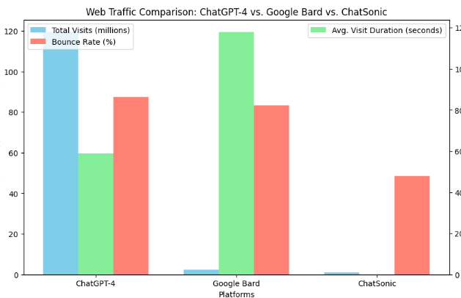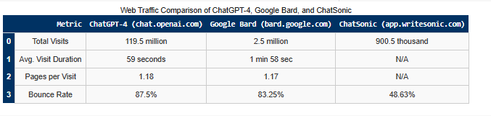

**Conclusion:**

ChatGPT-4 leads in overall traffic and engagement, indicating higher user adoption. Google Bard shows moderate traction, while ChatSonic has limited reach. These insights suggest ChatGPT currently dominates the AI chatbot space in terms of visibility and usage.